**LOGIN:**

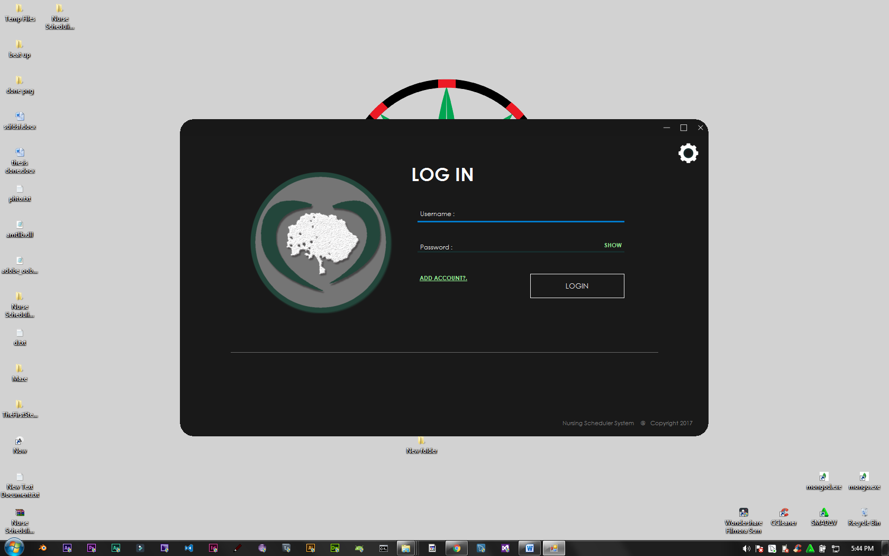

* **Input a correct and existing username and password to manage schedules**
* **If you don’t have an account, you can click the “ADD ACCOUNT” link to register**

**REGISTER**

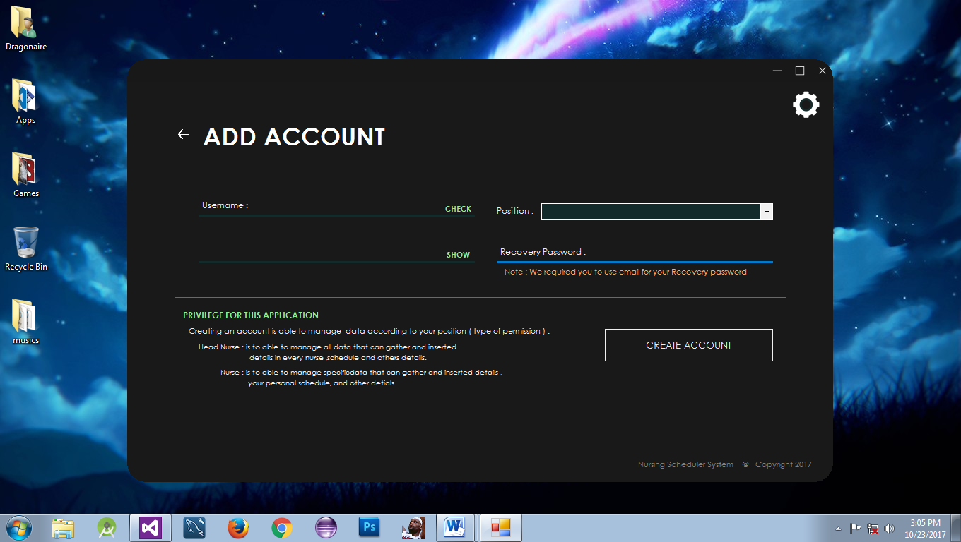

* **In this form, you can create an account to able to login.**

**MANAGING SCHEDULE FORM AFTER LOGIN:**

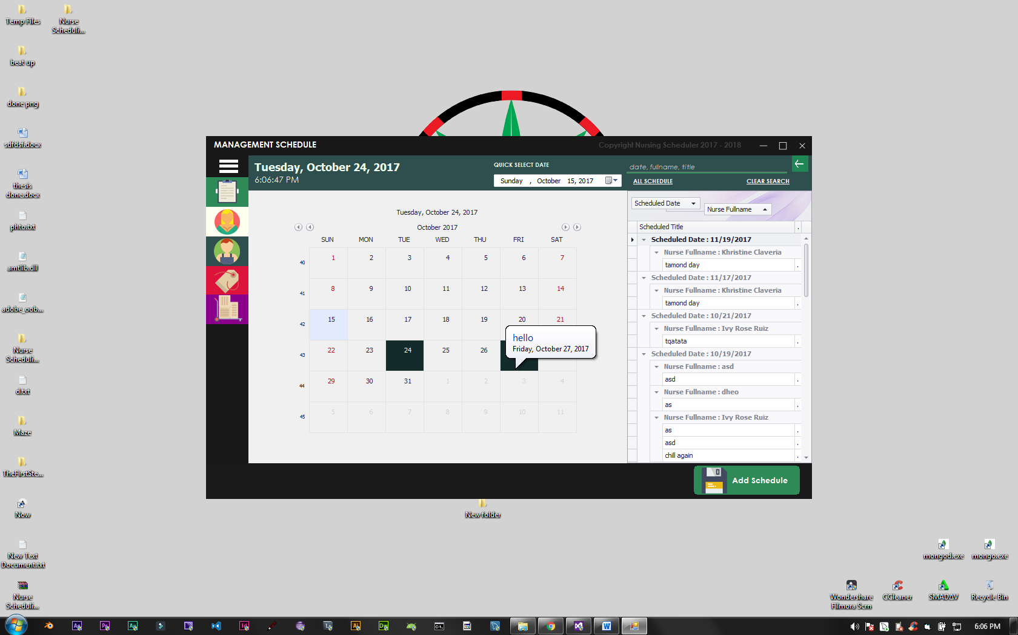

* **You can view, search, and manage your schedules in this form.**
* **Right click a calendar date to manage schedules on that day.**

**ADD NEW SCHEDULE:**

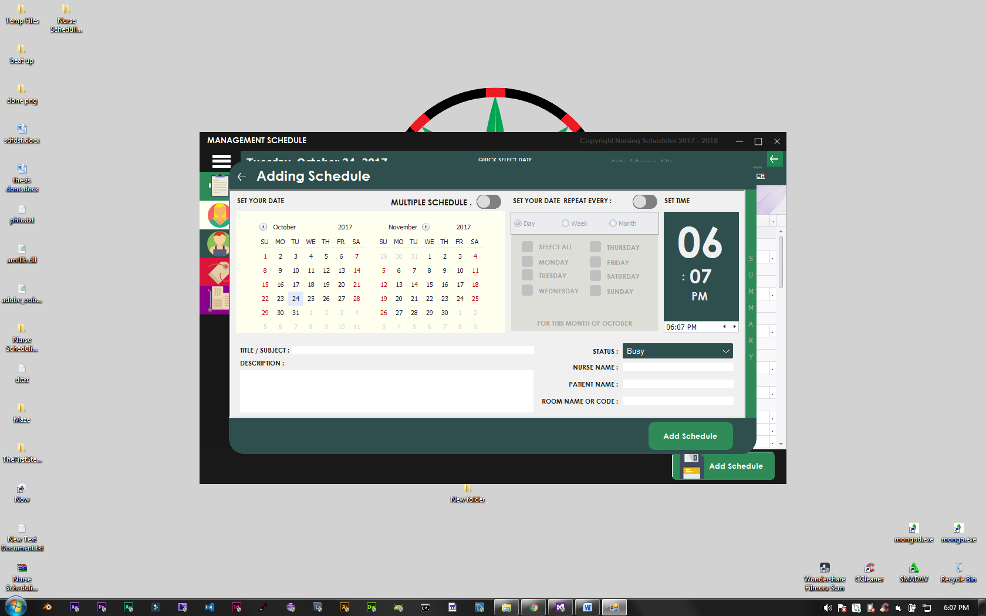

**- You can add schedule depending on what you want. You can add multiple, single, and repeating schedule.**

**- You can assign a nurse, patient, and room to that schedule.**

**MANAGING AND UPDATING OF SCHEDULE**

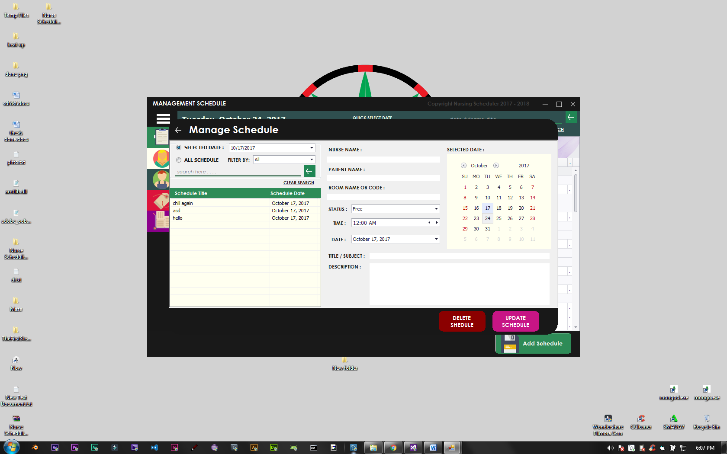

* **In this form, you can update your existing schedules.**
* **You can select specific date that you want to update.**

**MANAGING NURSES :**

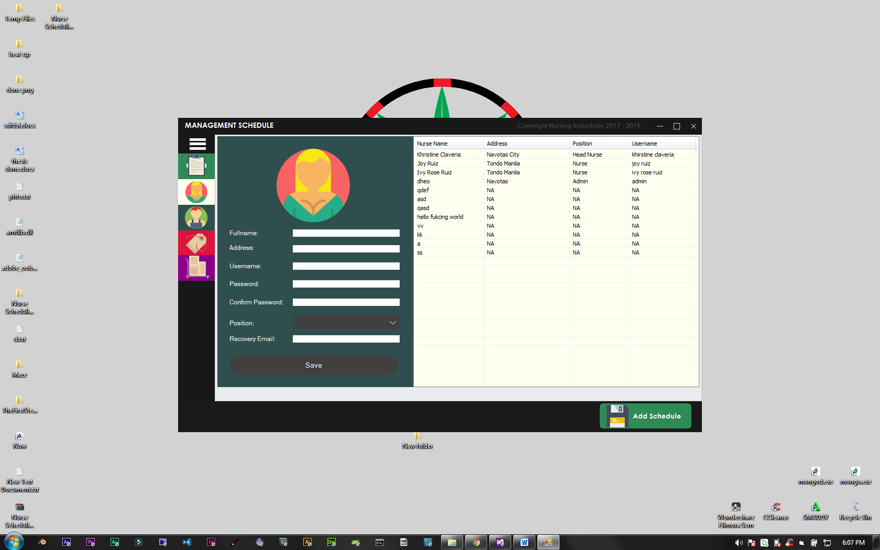

* **You can add new Nurse in this form**
* **You can update nurses in this form**
* **You can create accounts for existing nurses that doesn’t have an account**
* **You can delete nurse account here**

**MANAGING PATIENT:**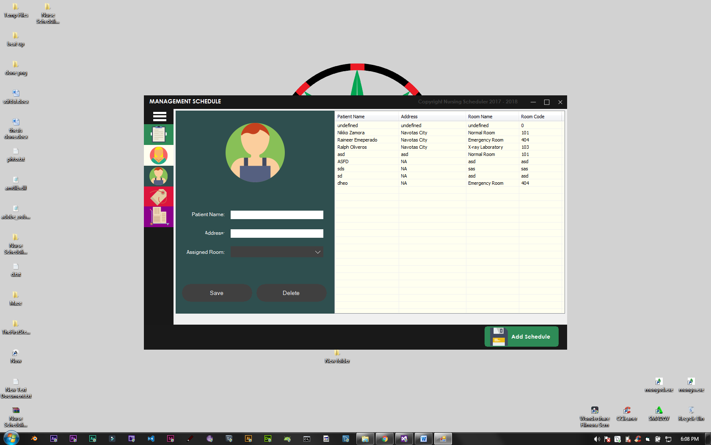

* **You can add Patients here**
* **You can update Patient information here**
* **You can assign them to a room**
* **You can delete patient information here**

**MANAGING ROOMS:**

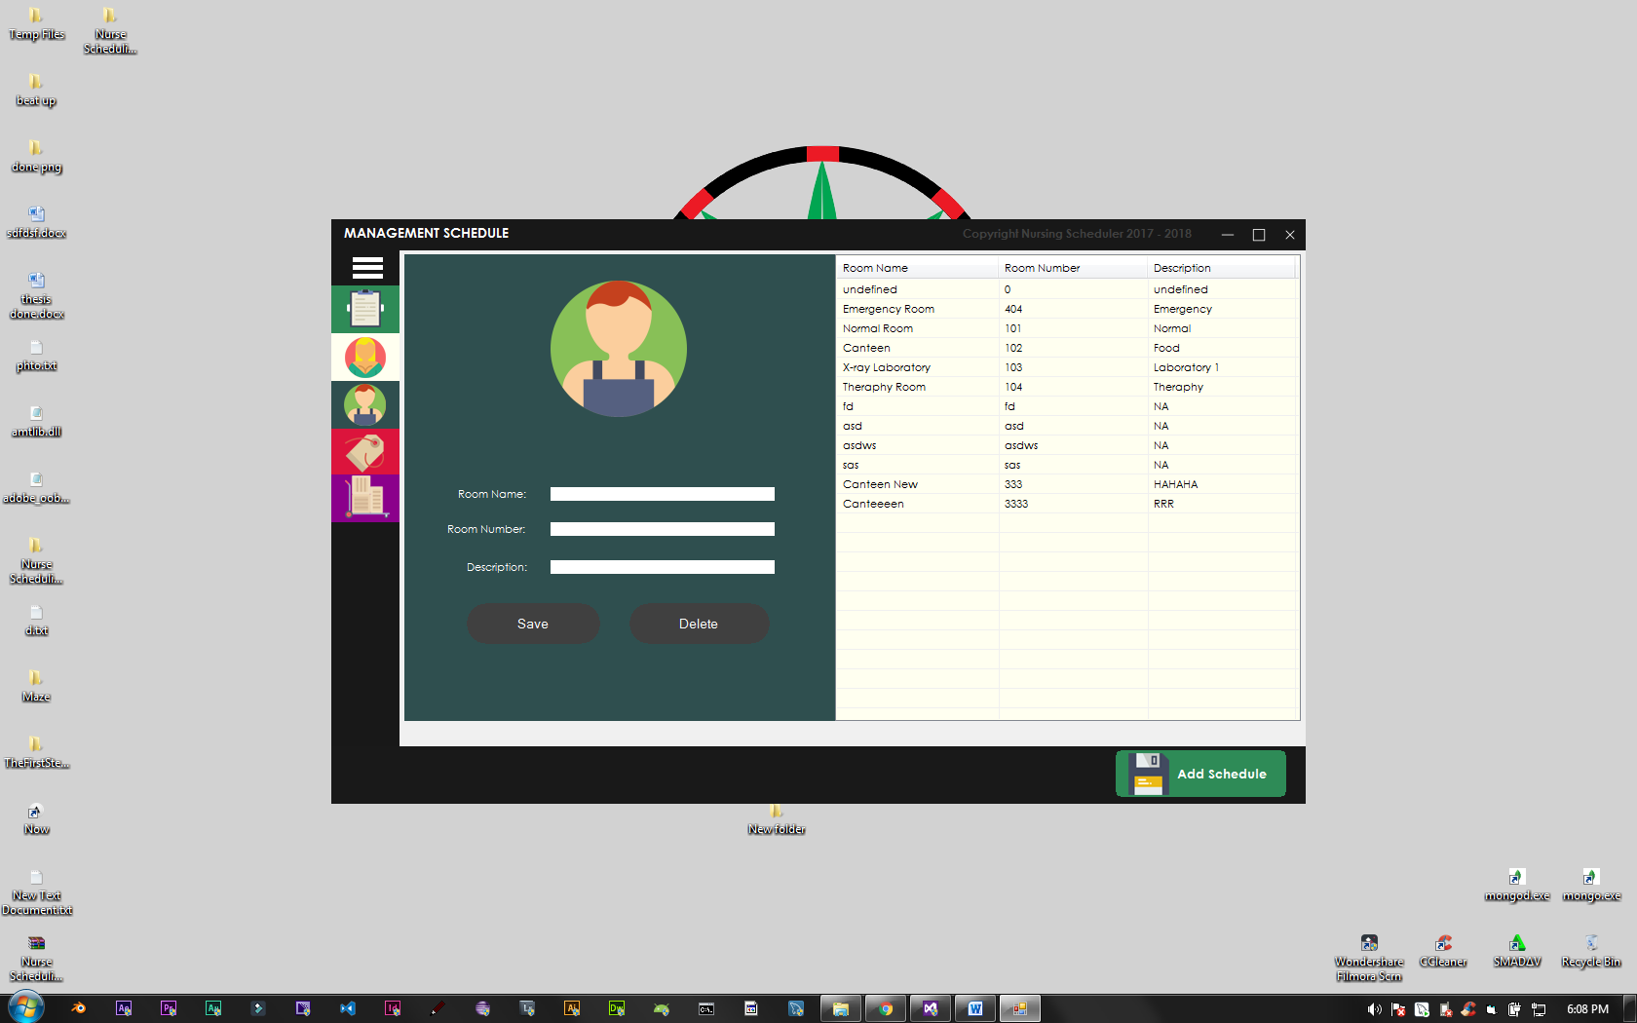

* **You can add Rooms here**
* **You can update rooms**
* **You can delete existing rooms here**

**SUPPLIES TRANSACTION:**

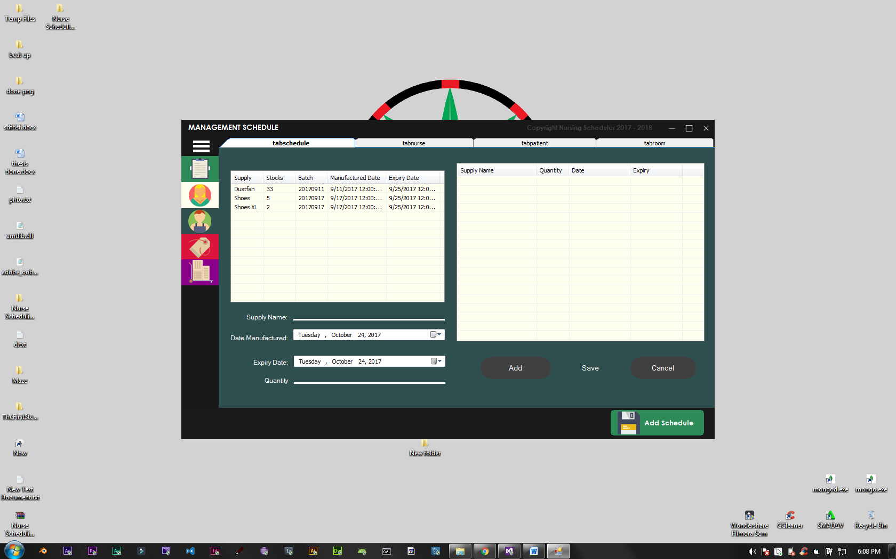

* **You can manage transaction here**
* **Transaction with single item**
* **Transaction with multiple item**
* **Print transactions to excel**

**MEDICINE TRANSACTION:**

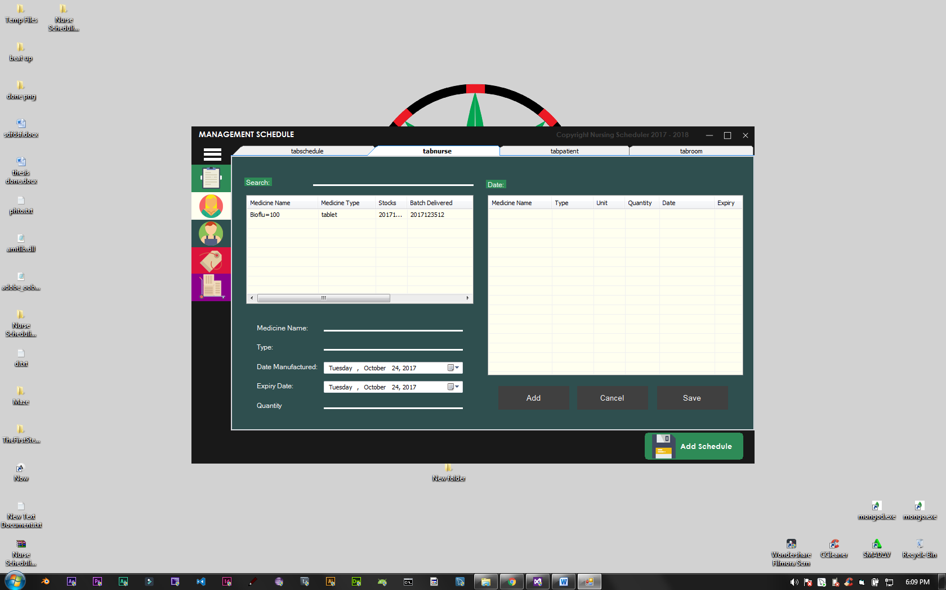

* **You can manage Medicines here**
* **Transaction with single medicine**
* **Transaction with multiple medicine**
* **Print transaction to excel**

**MEDICINE INVENTORY:**

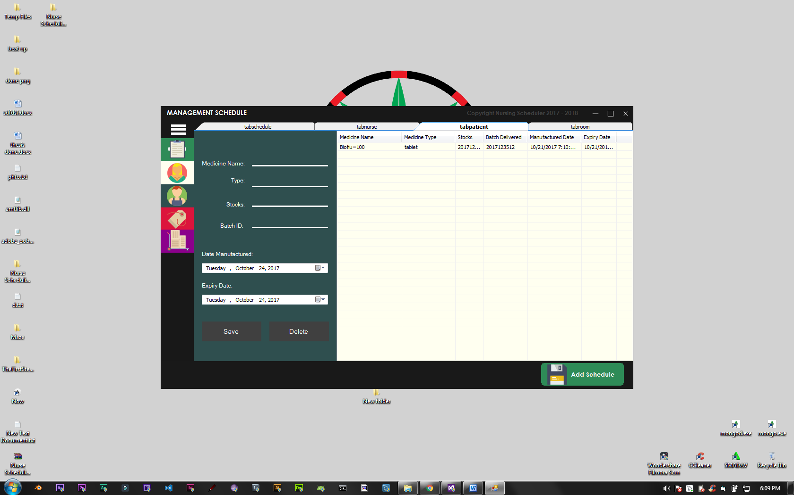

* **Add new Medicine**
* **Update medicine**
* **Delete medicine**

**SUPPLIES INVENTORY:**

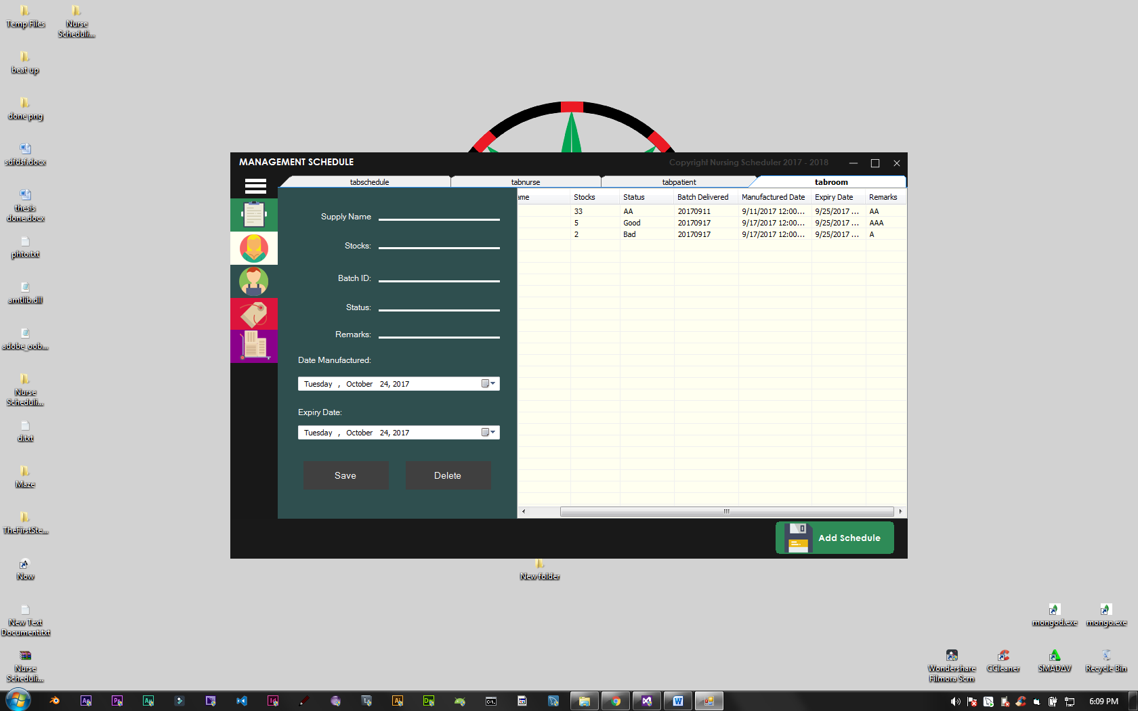

* **Add new Supplies**
* **Update existing supplies**
* **Delete existing supplies**